**Jenkins End to End CICD Pipeline Implementation**

1. Installation of ec2 instance

* Go to the aws console
* Create and launch the ec2 instance
* ultimate-cicd instance is running now.

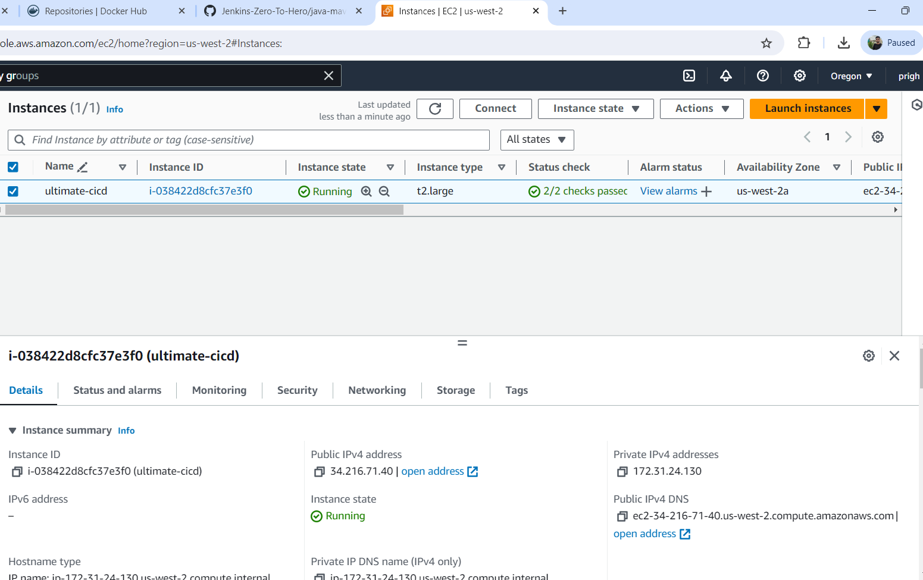

1. Now I connected the ec2 instance on mobaXterm.
2. Install the Jenkins

Pre-Requisites: • Java (JDK) Run the below commands to install Java and Jenkins

Install Java

*sudo apt update*

*sudo apt install openjdk-17-jre*

Verify Java is Installed

*java -version*

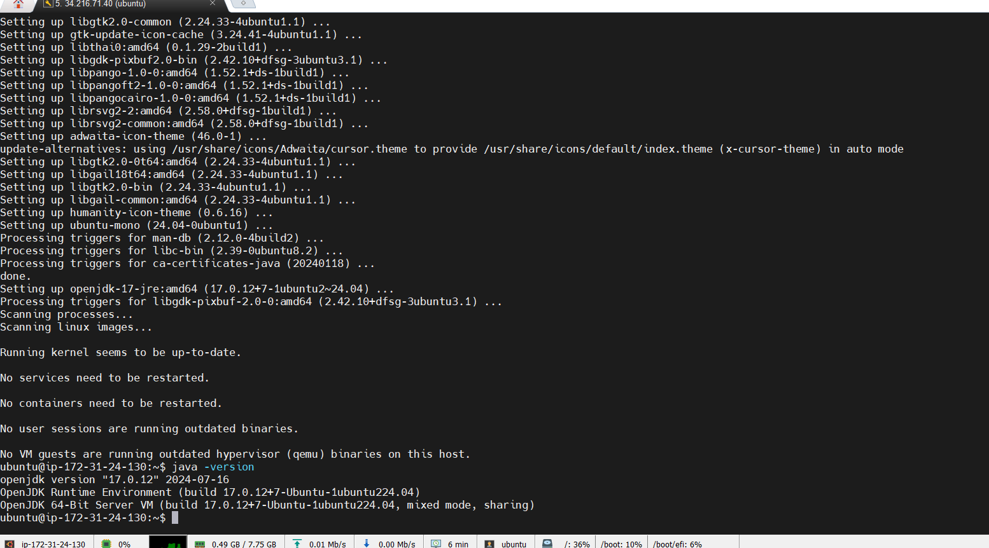

1. Now we can proceed to install Jenkins

*curl -fsSL*[*https://pkg.jenkins.io/debian/jenkins.io-2023.key*](https://pkg.jenkins.io/debian/jenkins.io-2023.key)*| sudo tee  
/usr/share/keyrings/jenkins-keyring.asc > /dev/null echo deb [signed-by=/usr/share/keyrings/jenkins-keyring.asc]*[*https://pkg.jenkins.io/debian*](https://pkg.jenkins.io/debian)*binary/ | sudo tee  
/etc/apt/sources.list.d/jenkins.list > /dev/null*

*sudo apt-get update*

*sudo apt-get install jenkins*

1. Jenkins is installed but it will not allow inbound traffic to the external due to restriction of aws. So, we need to allow the traffic

* Go to the running ec2 instance
* Go to the below tab security group -> click on that group name -> add the inbound traffic rules.

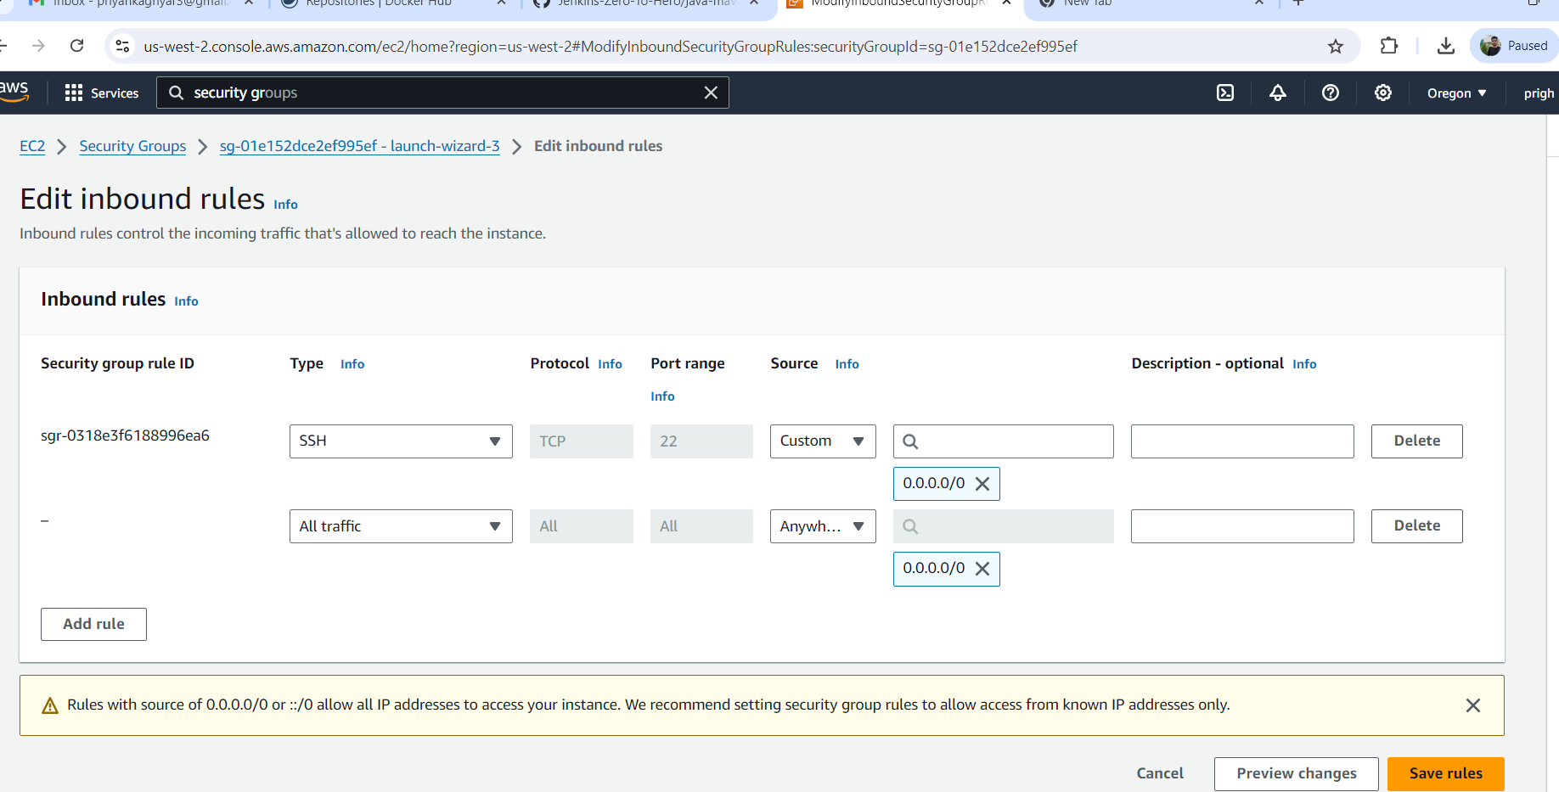

1. Check the port of jenkins

*ps -ef | grep Jenkins*

We can see the http port is 8080

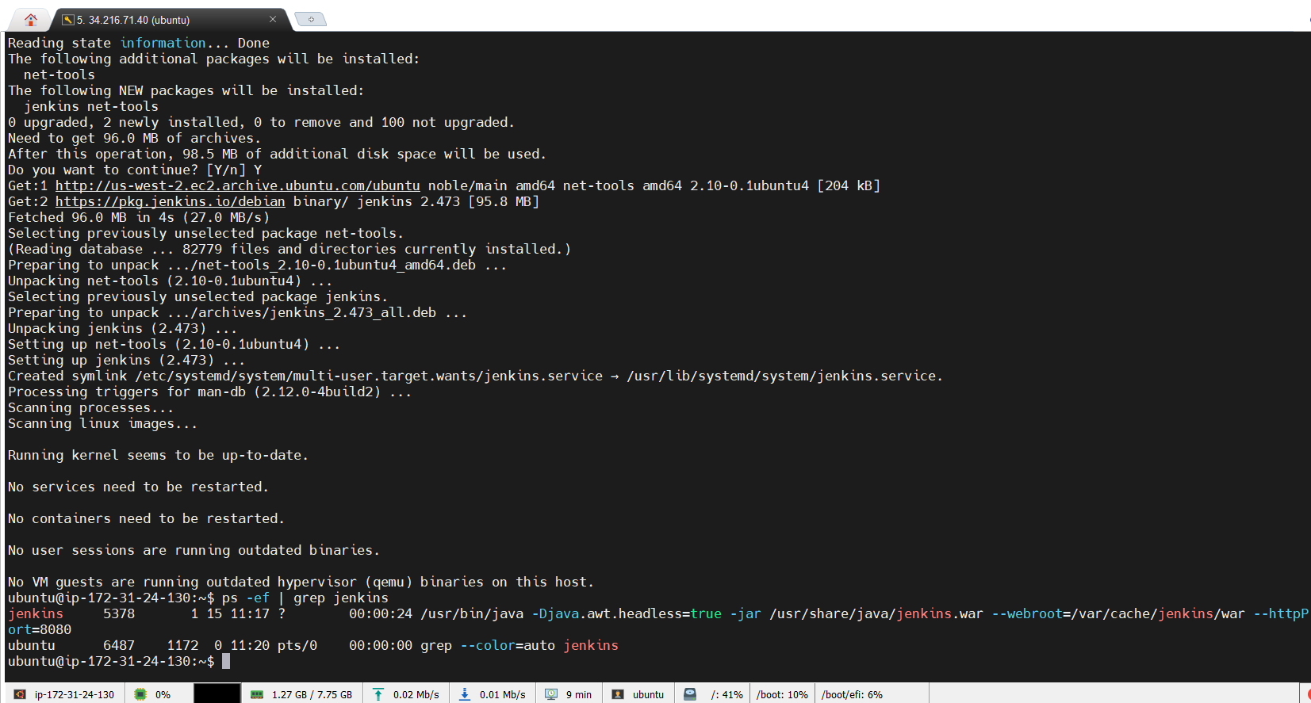

1. Login the Jenkins

* <ec2instance Ip address>:8080

After login -> to know the password use the command. *sudo cat <path>*

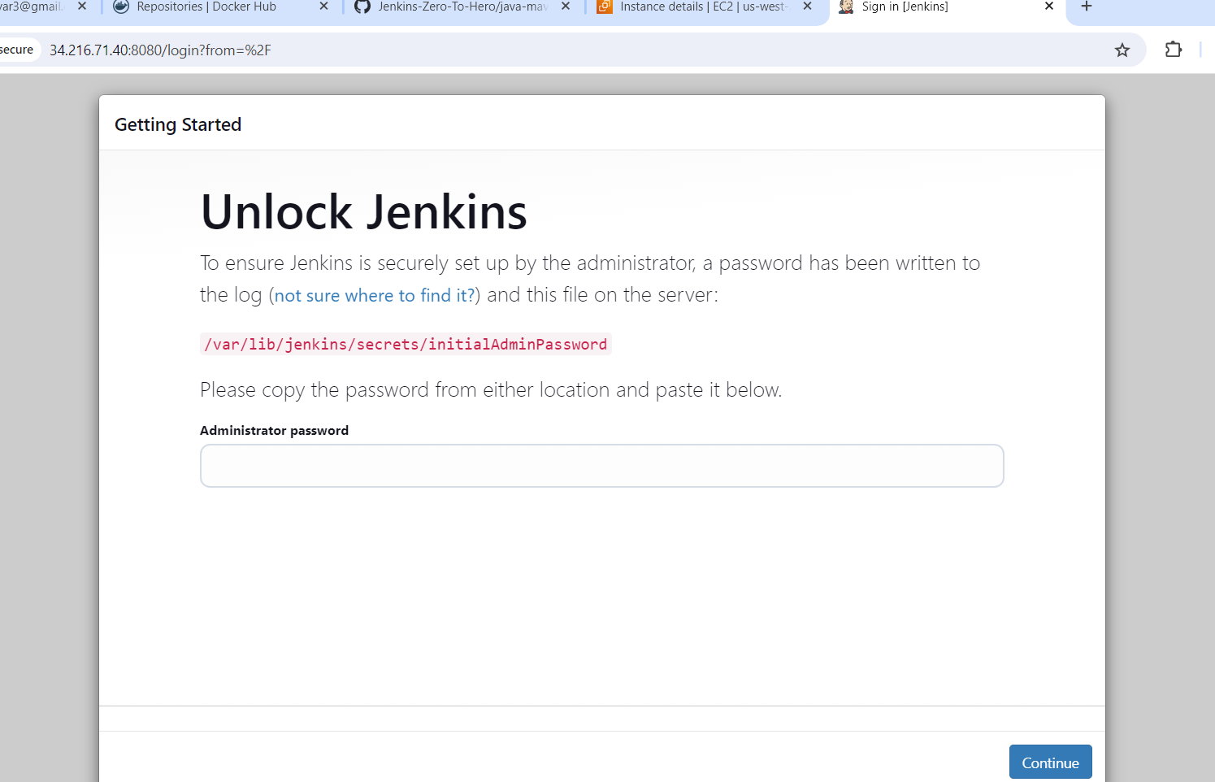

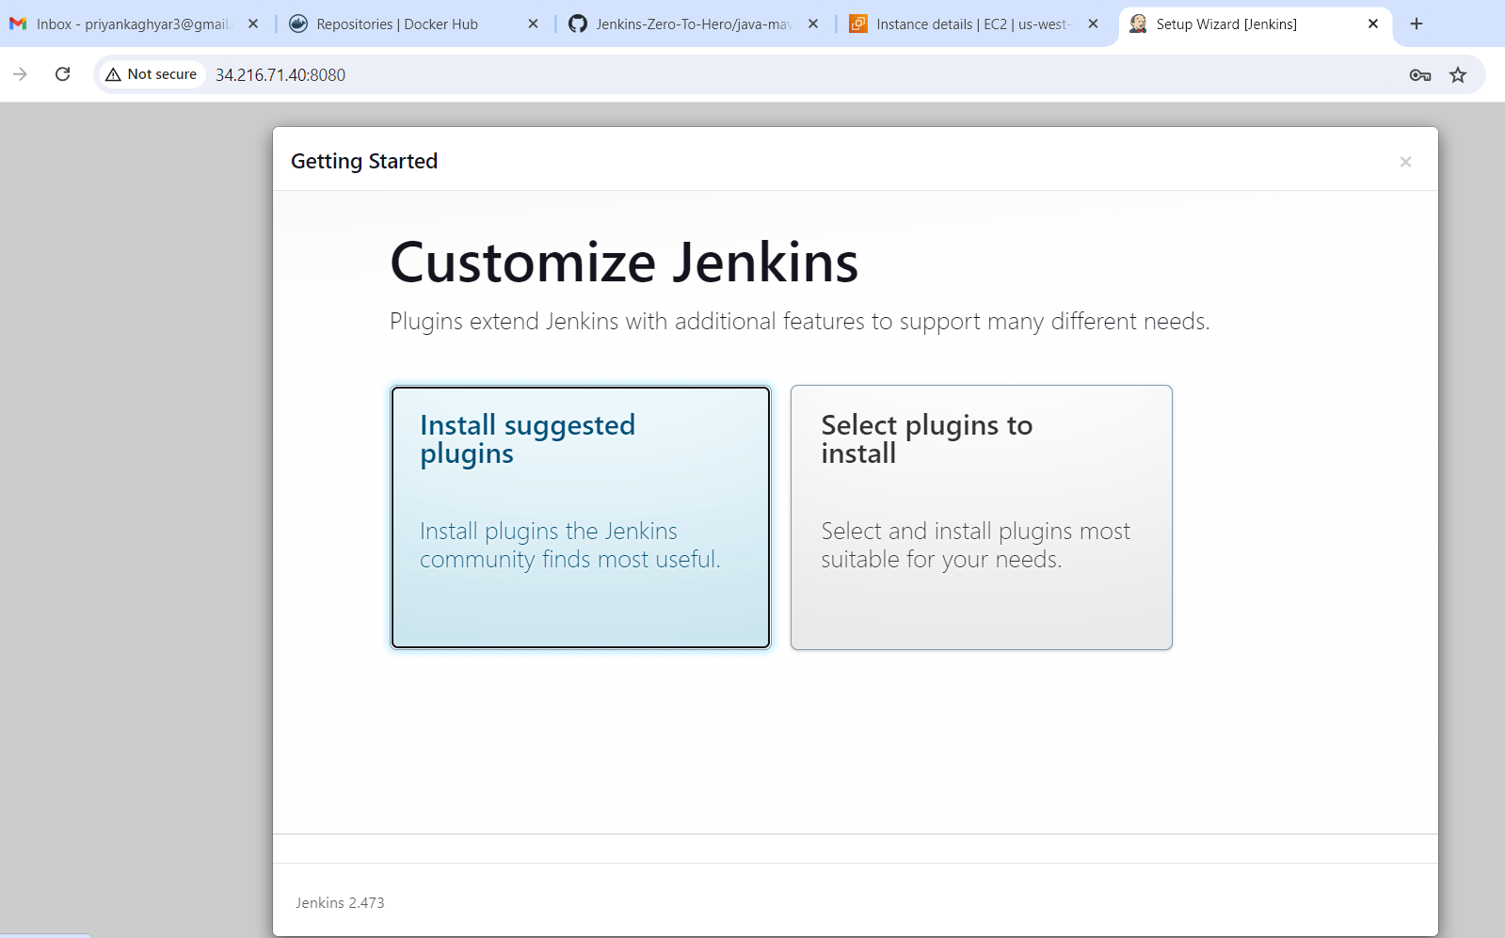

Jenkins is ready now 😊

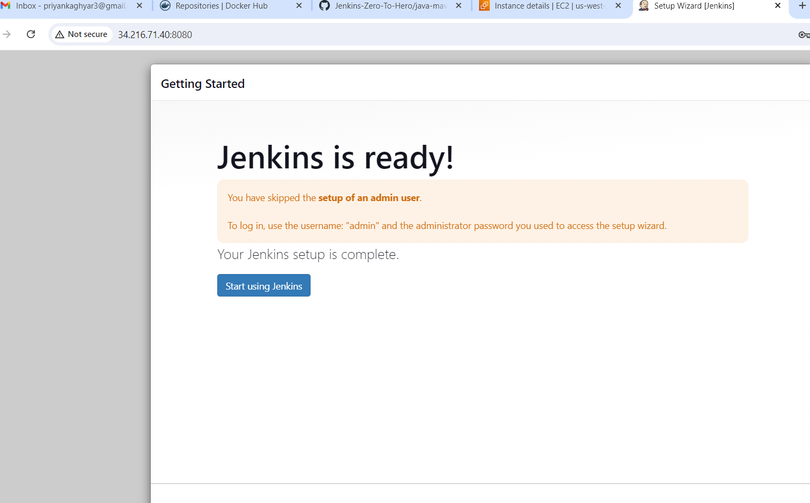

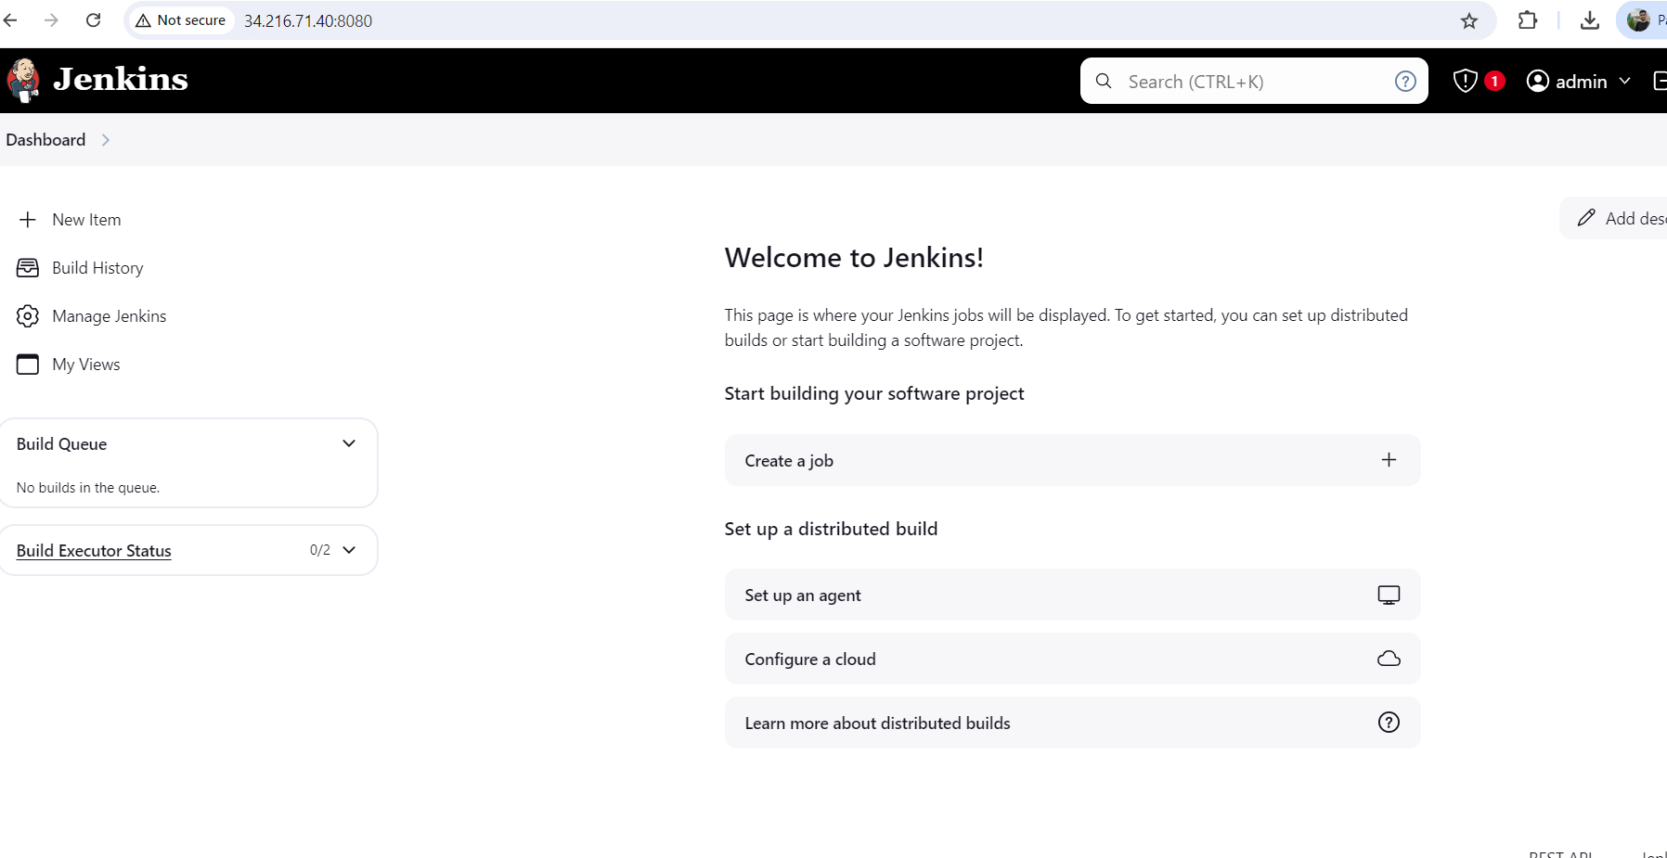

1. Click on new item. And configure the new item -> *ultimate-demo*

* Configure the pipeline
* Add definition, repository URL, branch, script-path and apply.

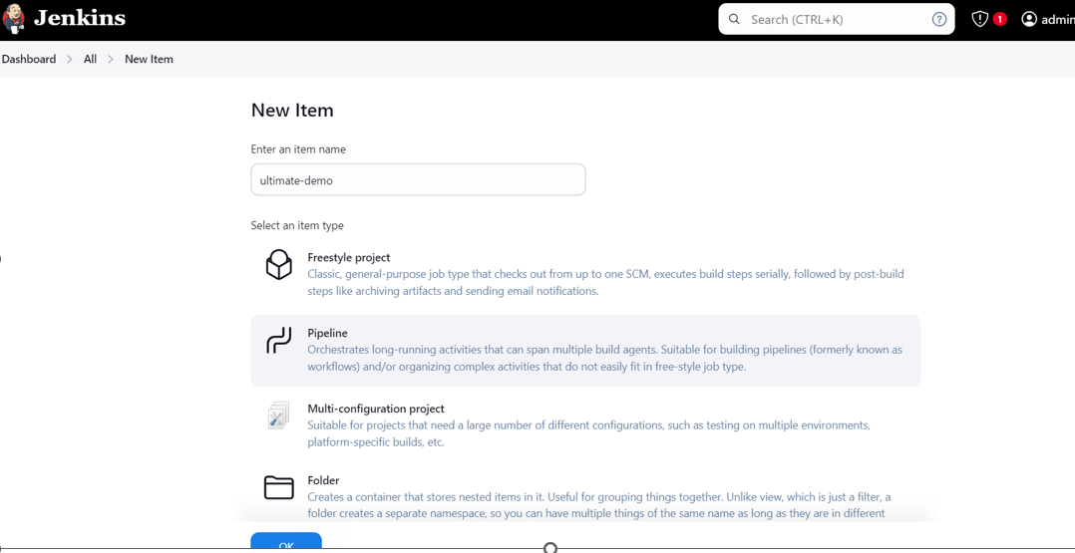

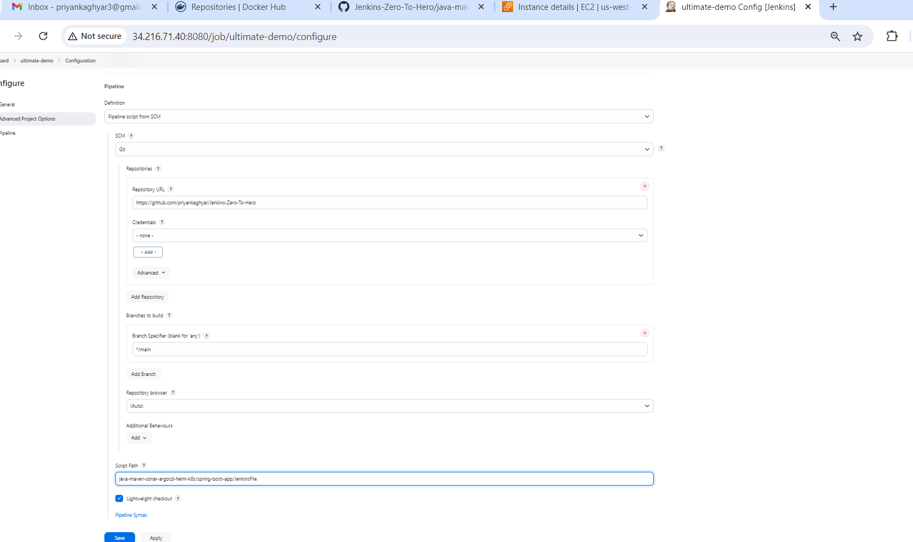

1. Manage the plugin

* Add Docker plugins
* Add Sonarqube Plugins

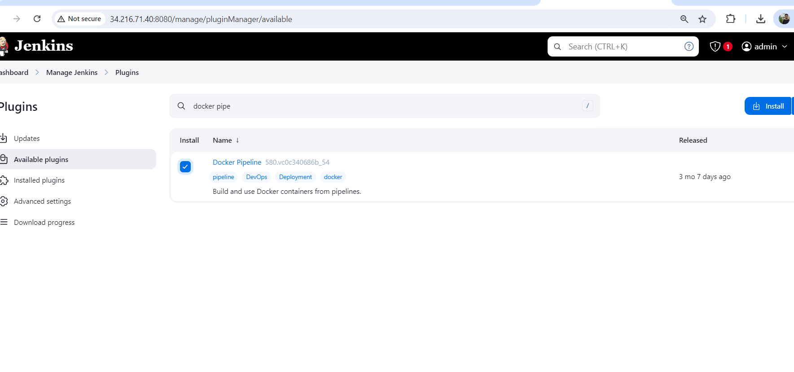

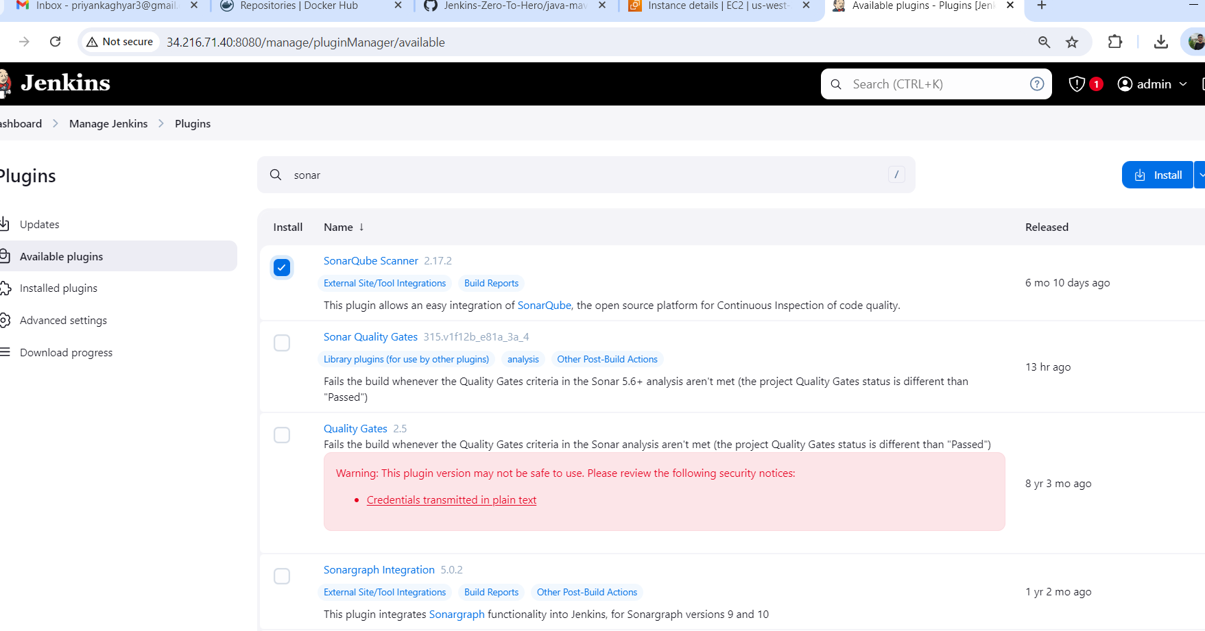

1. Now Configure the Sonar Server locally

*apt install unzip*

*adduser sonarqube*

*wget https://binaries.sonarsource.com/Distribution/sonarqube/sonarqube-9.4.0.54424.zip*

*unzip \**

*chmod -R 755 /home/sonarqube/sonarqube-9.4.0.54424*

*chown -R sonarqube:sonarqube /home/sonarqube/sonarqube-9.4.0.54424*

*cd sonarqube-9.4.0.54424/bin/linux-x86-64/*

*./sonar.sh start*

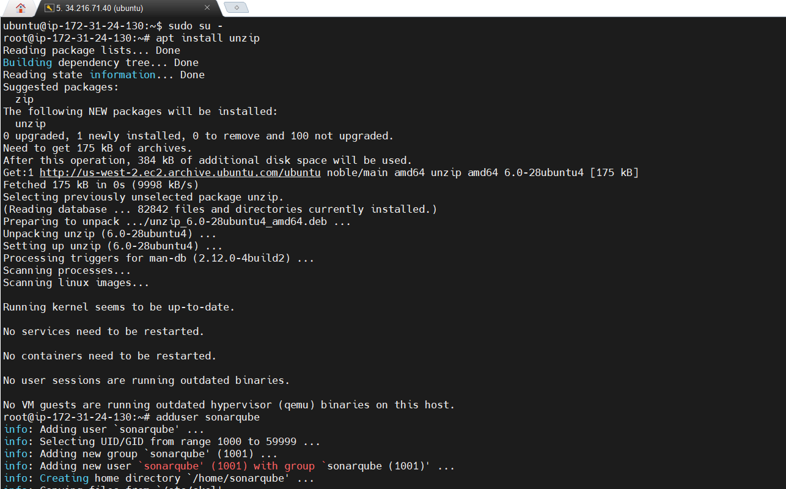

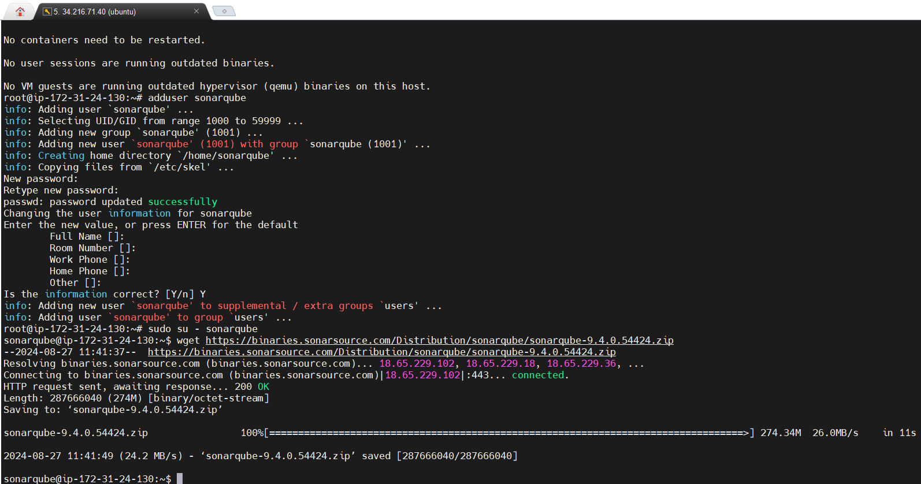

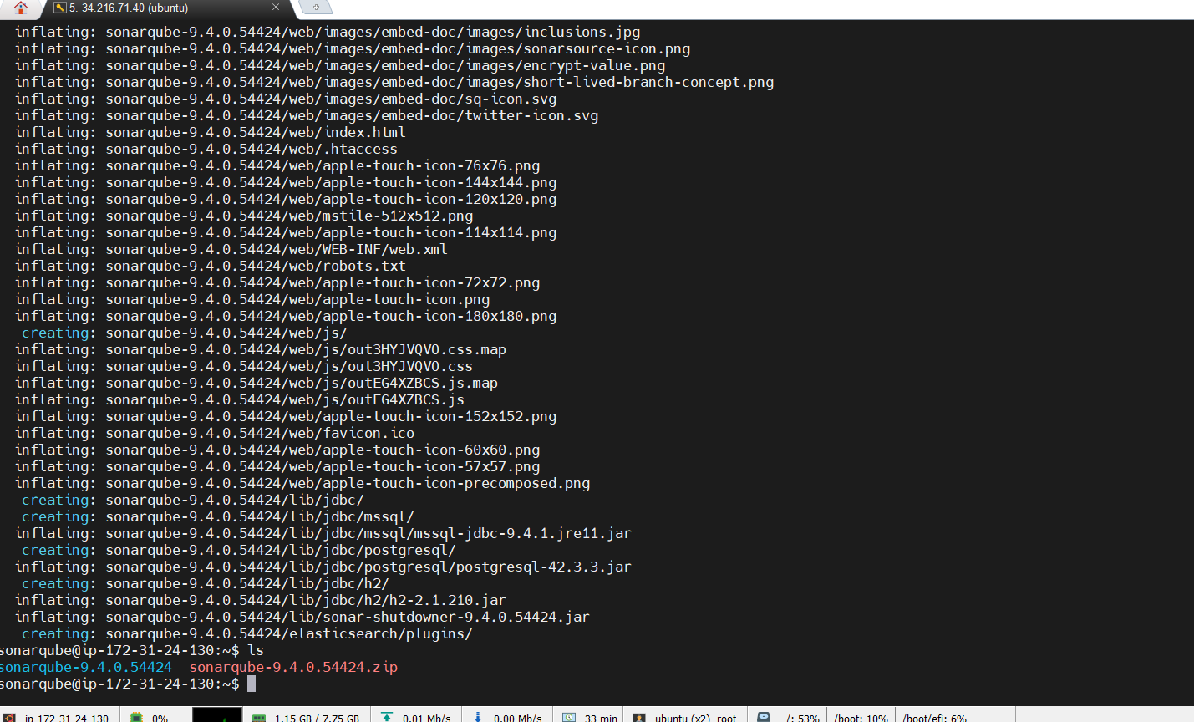

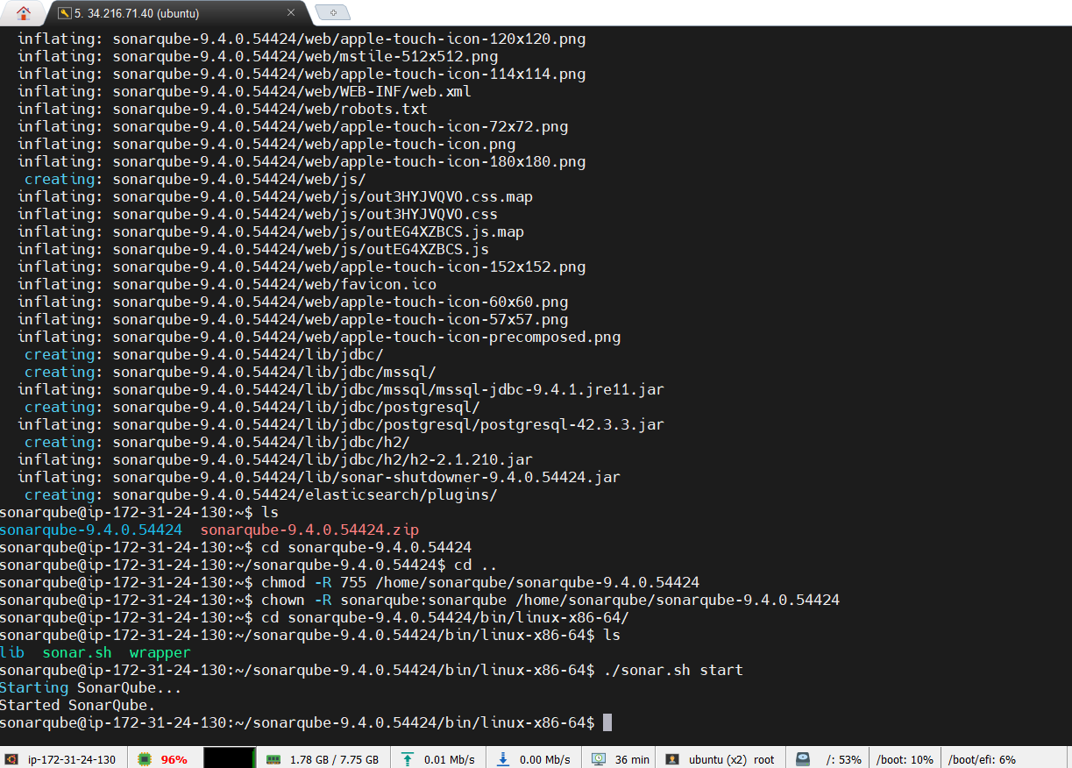

* SonarQube is started
* Login to SonarQube
* <ec2 ip>:9000
* Default username and password is admin

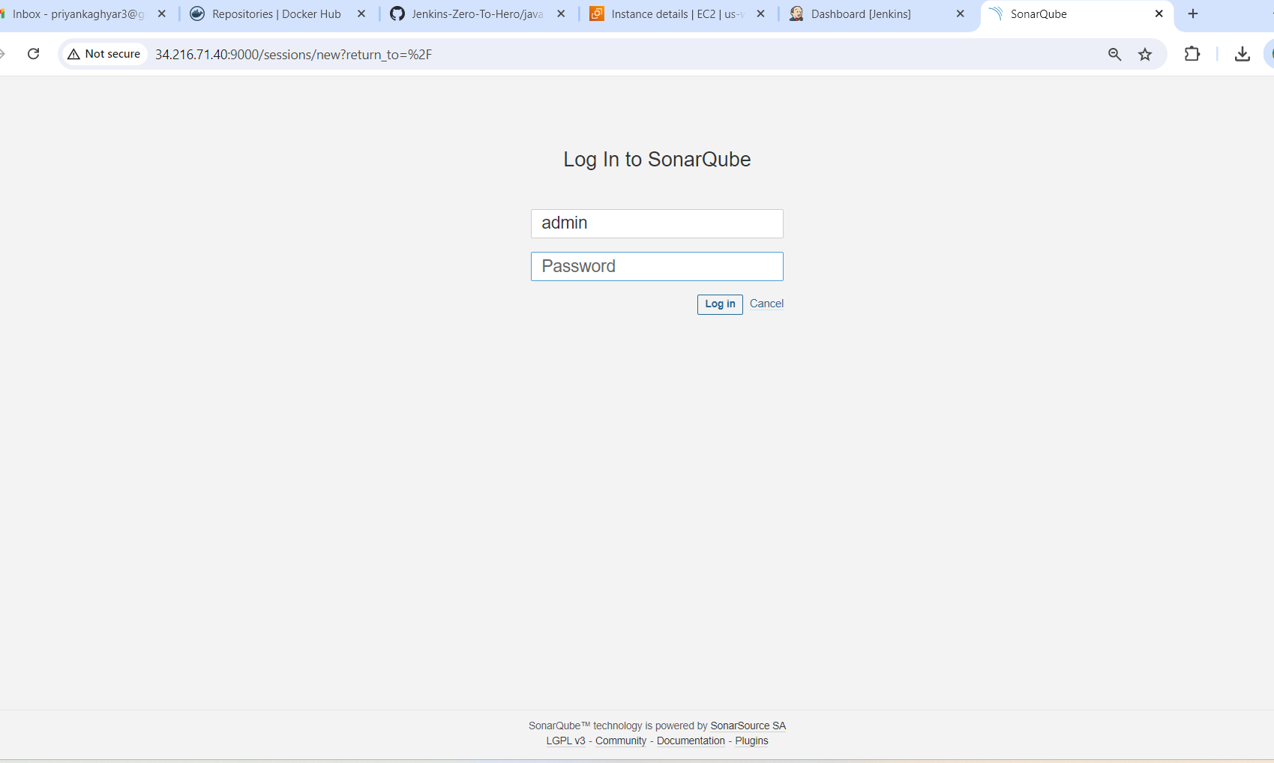

1. Generate the sonar token and add this token in Jenkins credential.

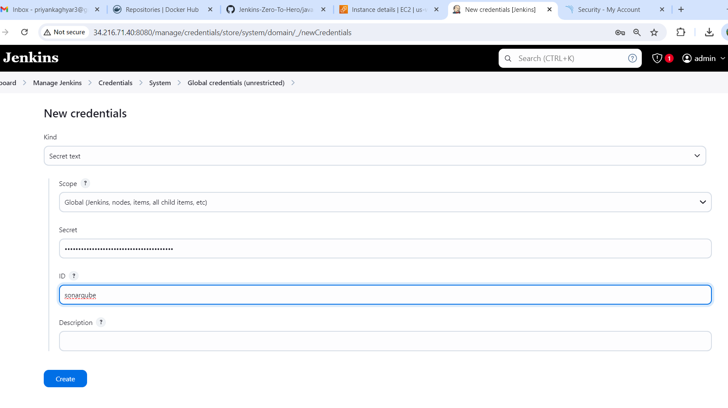

1. Install the docker agent on ec2 instance

*sudo apt update*

*sudo apt install docker.io*

1. We need to grant the ubuntu and Jenkins user to docker daemon

*sudo su -*

*usermod -aG docker jenkins*

*usermod -aG docker ubuntu*

*systemctl restart docker*

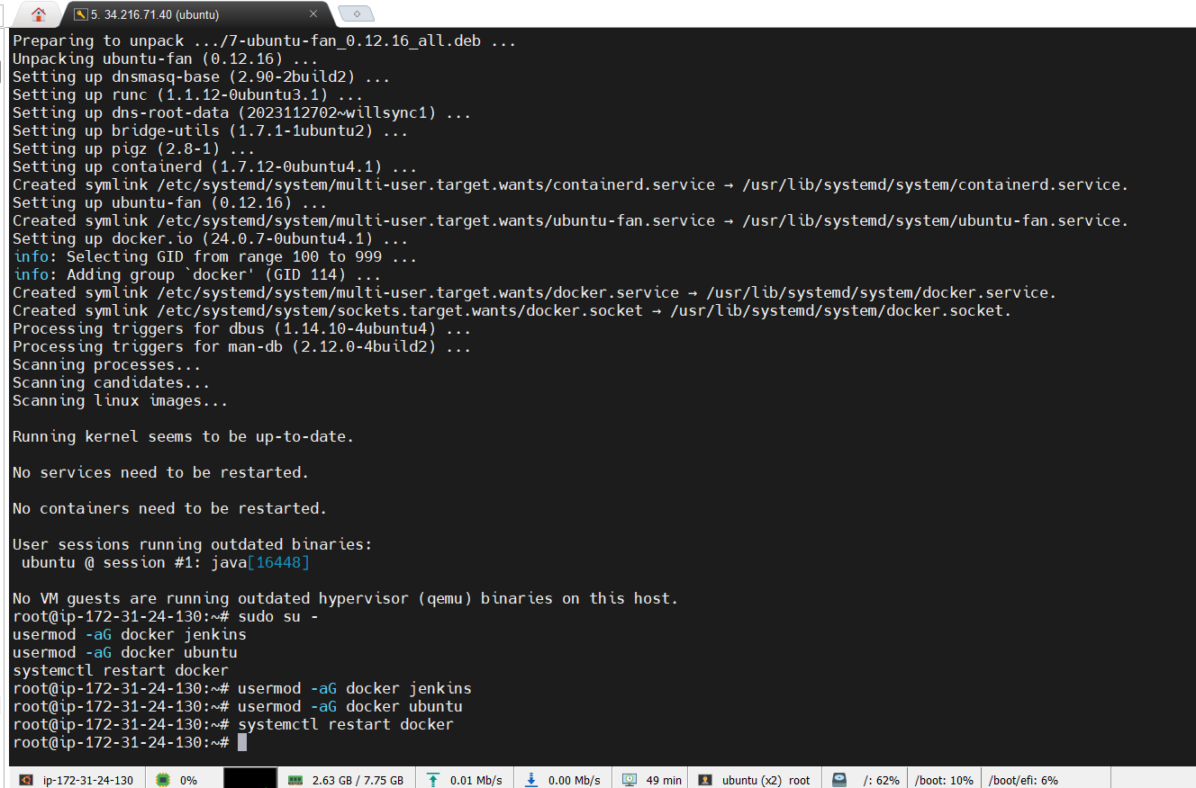

Restart Jenkins now

1. Install the minikube locally

* <https://minikube.sigs.k8s.io/docs/start/?arch=%2Fwindows%2Fx86-64%2Fstable%2F.exe+download>

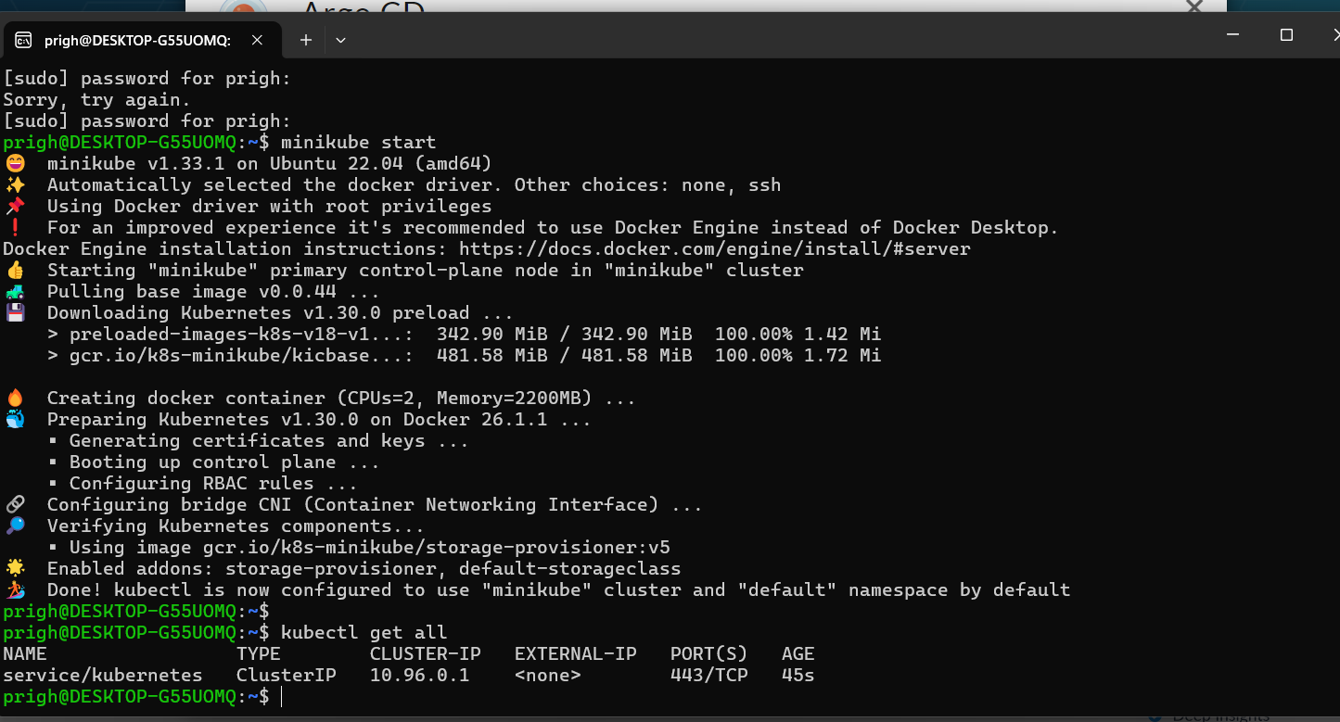

1. Install the argocd steps on operator hub site

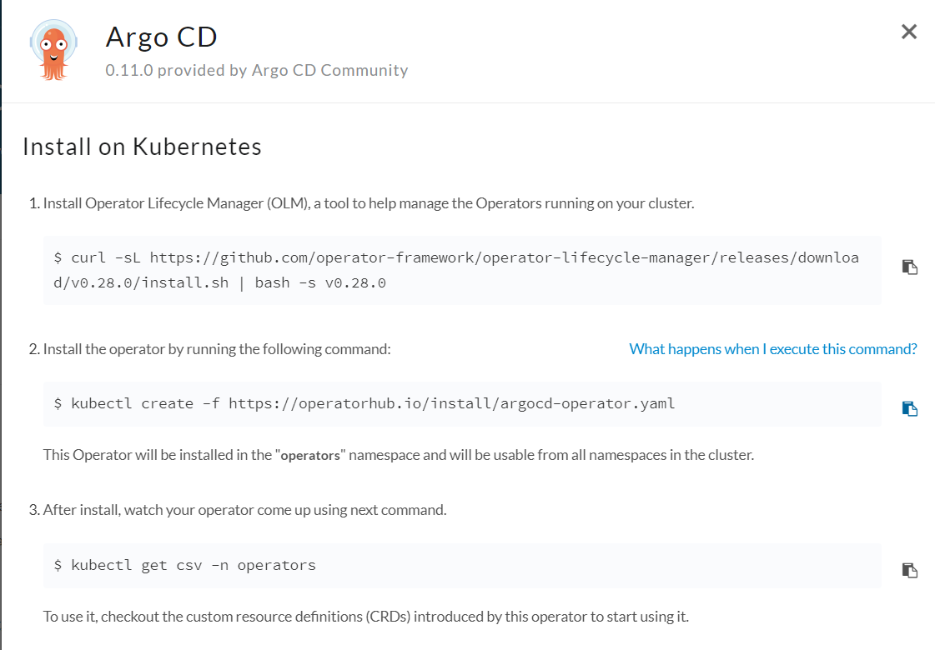

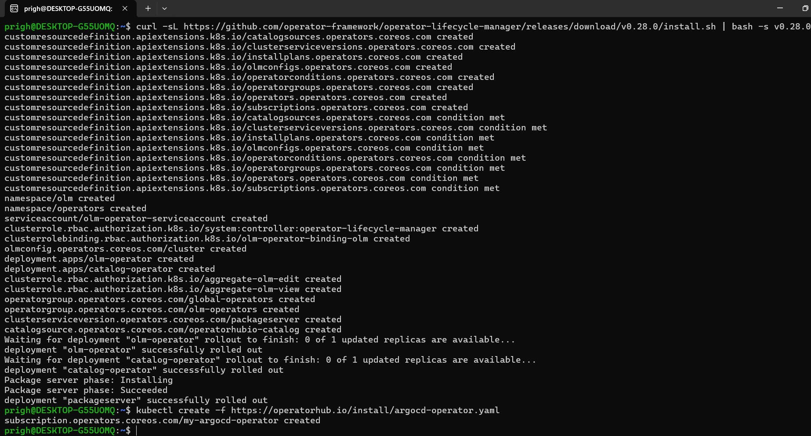

* To check the status of operator, use below command.

*kubectl get pods -n operators*

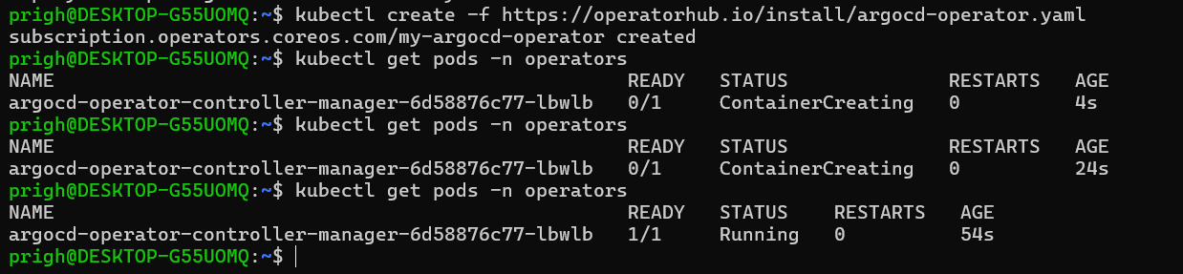

1. Added credentials on Jenkins: Docker and GitHub.

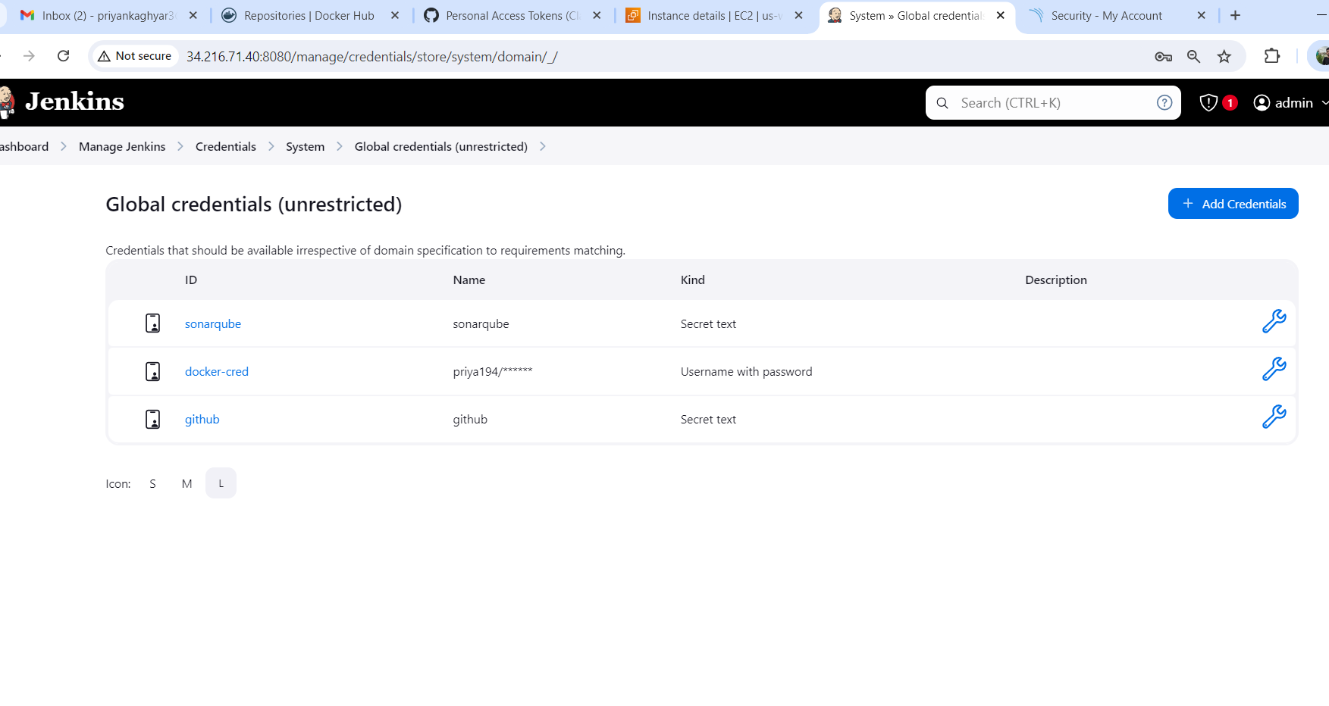

1. Restart the Jenkins and say build now 😊

* Pipeline is running it downloading dependencies, passing the stages.

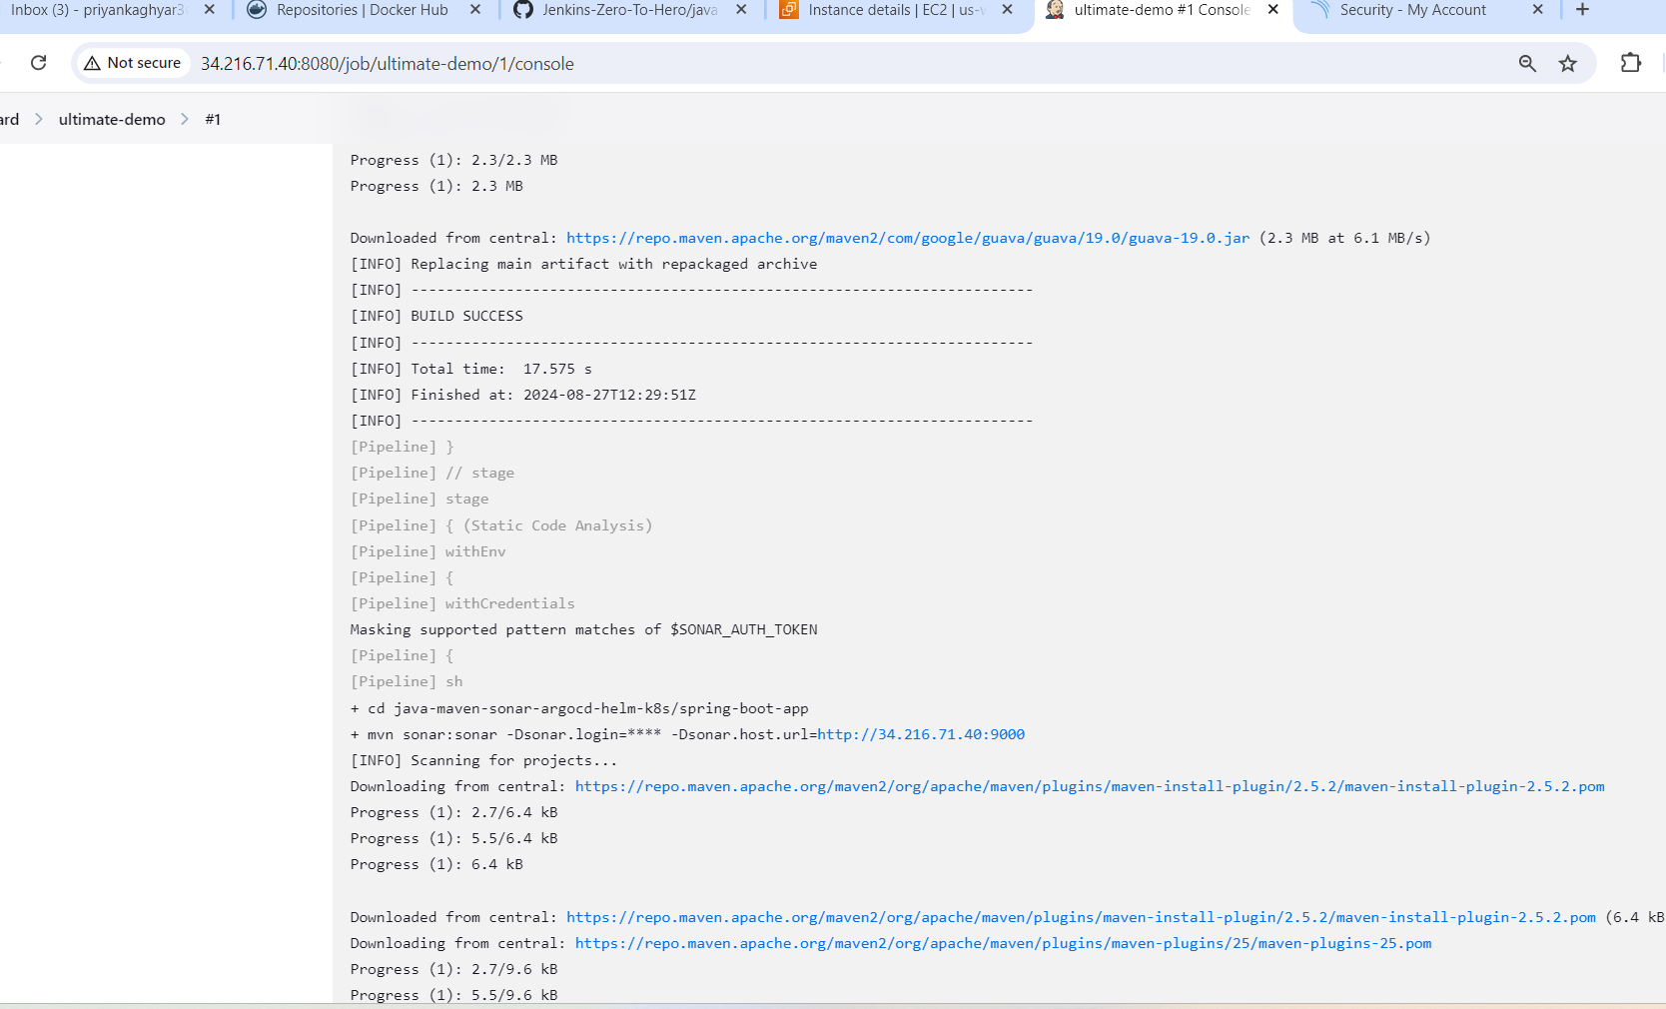

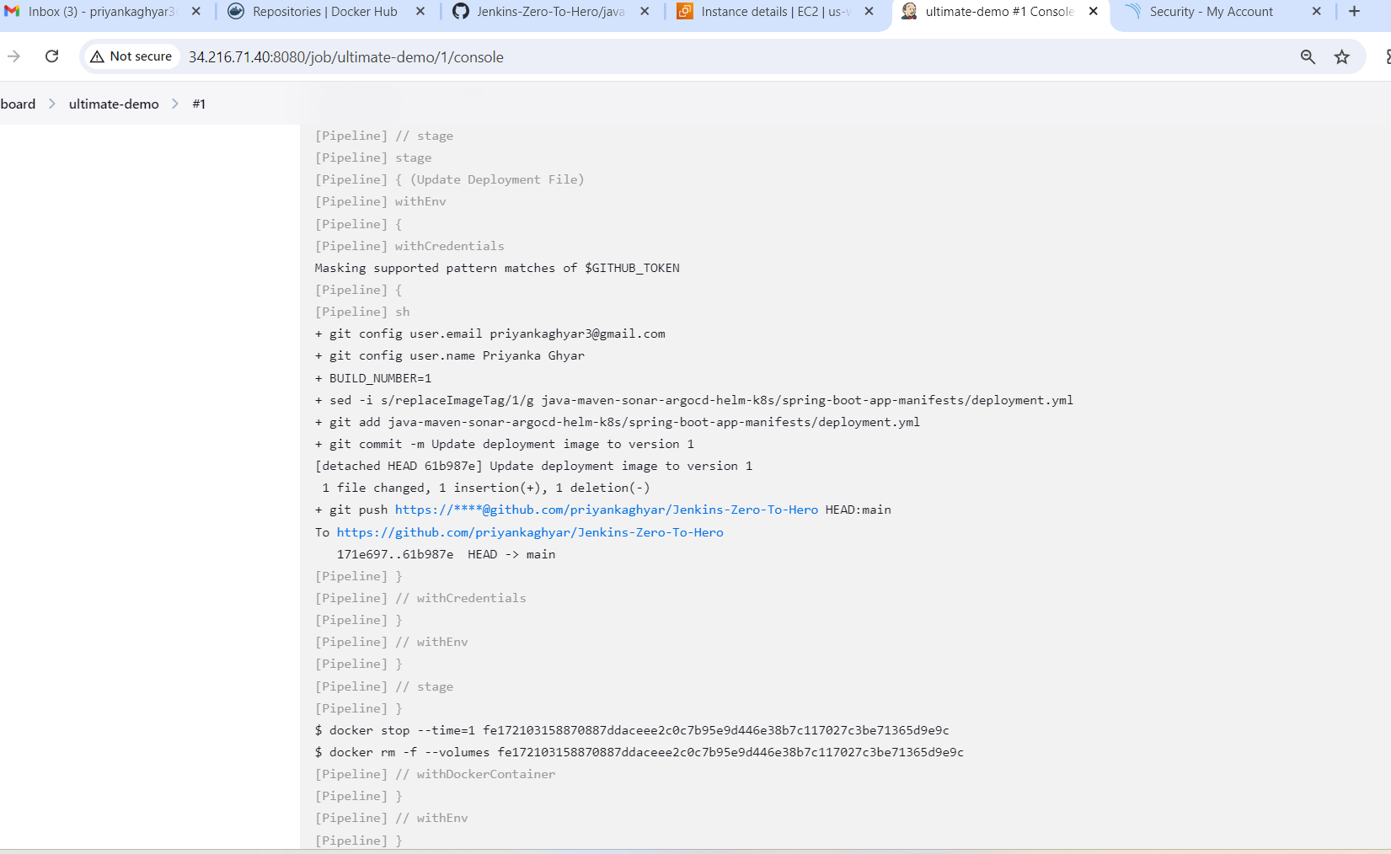

1. Stages of pipeline overview.

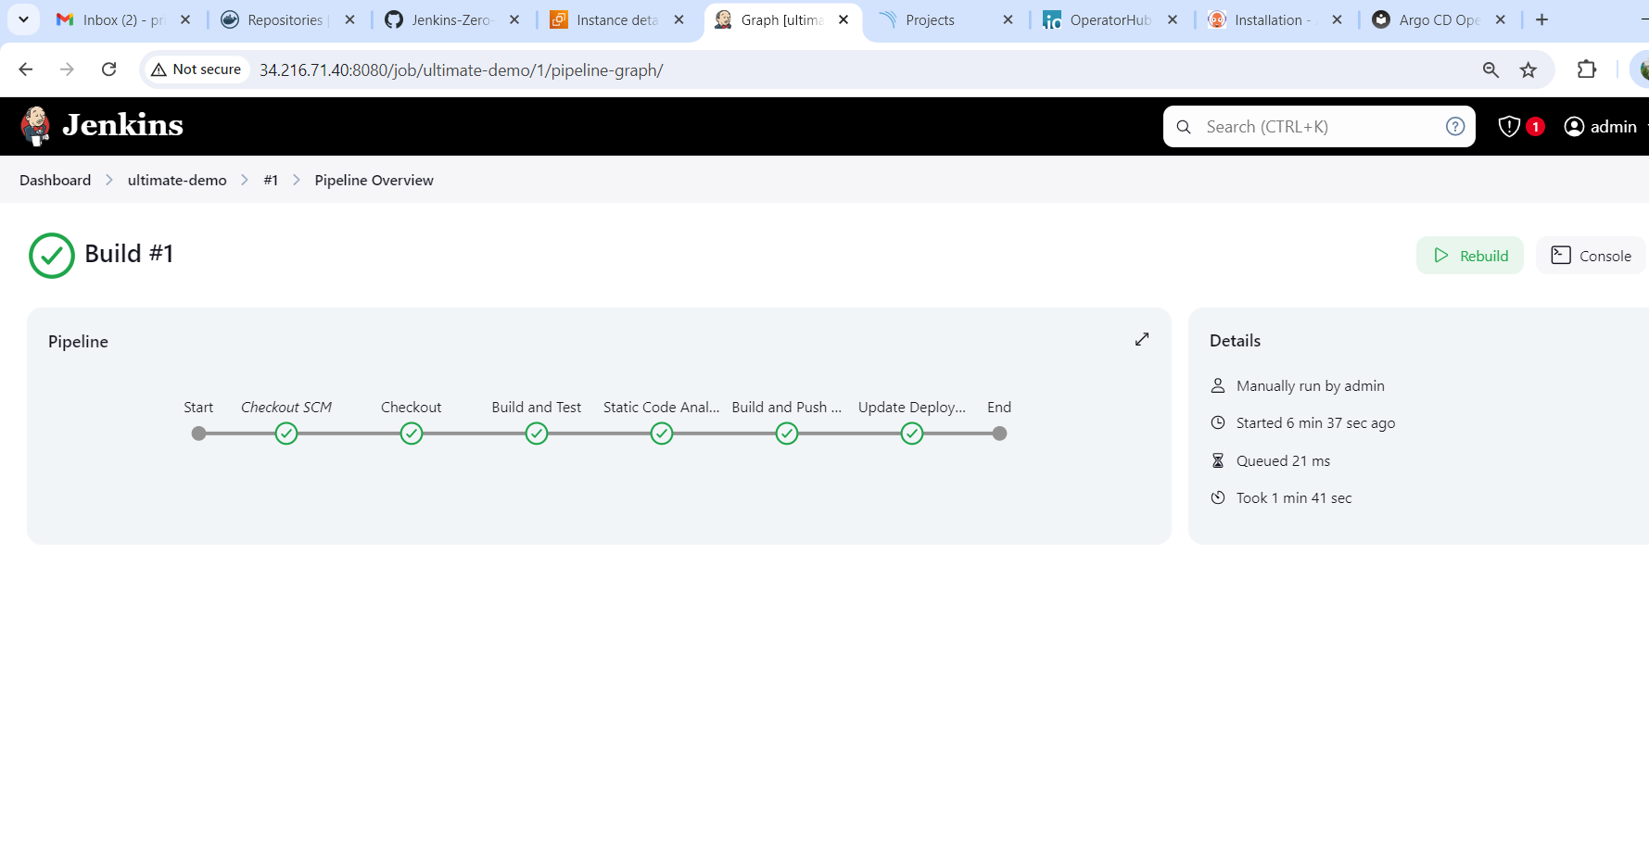

1. You can see in repository updated the deployment image to version 1. Tag is updated.

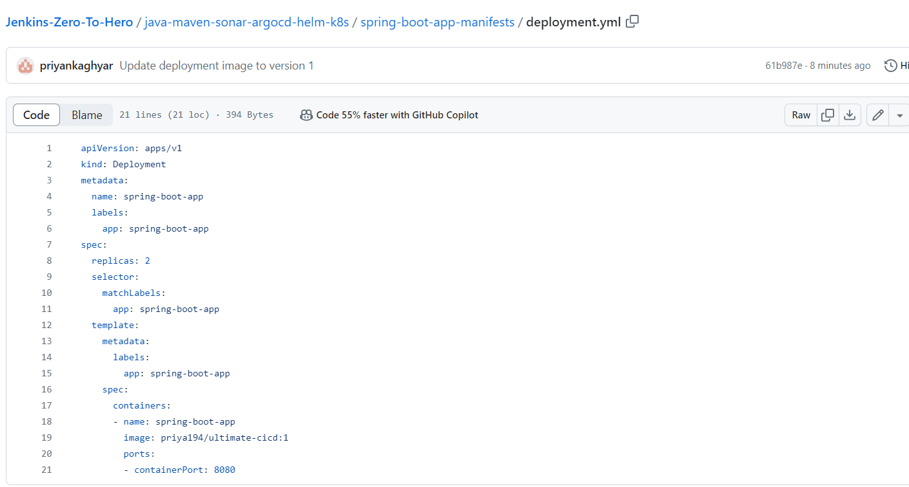

1. In the docker hub account image is created *priya194/ultimate-cicd:v1.*

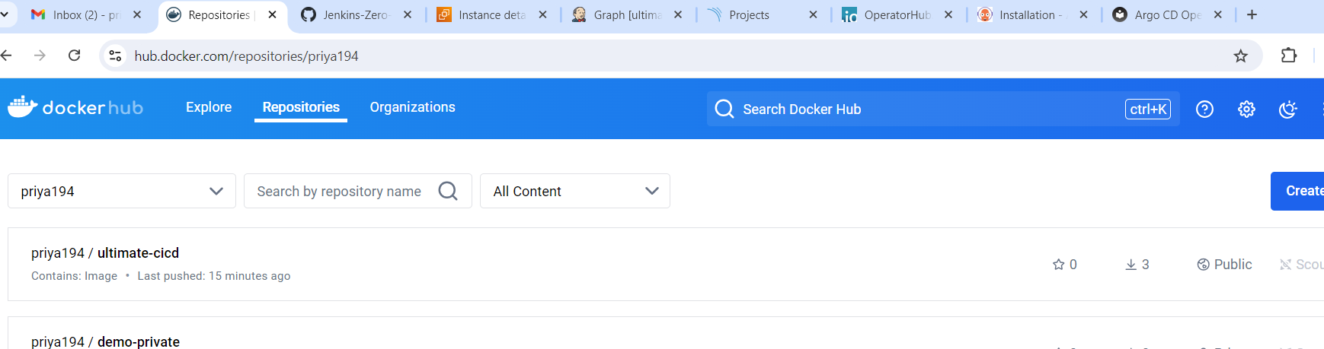

1. In the SonarQube Project code is scanned.

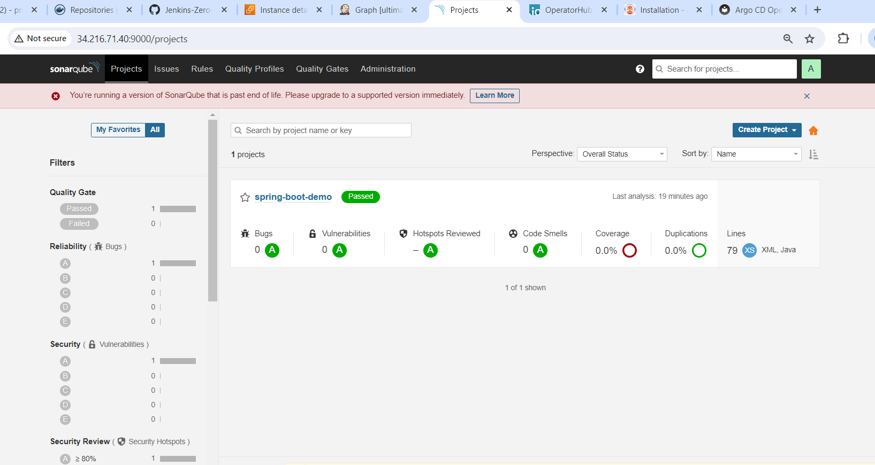

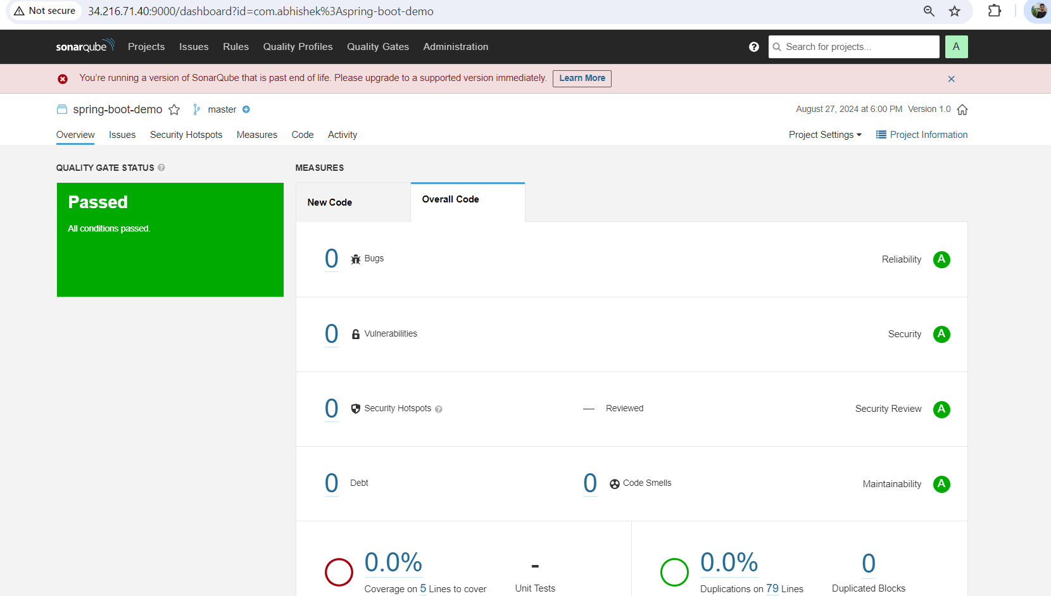

**CI part is done now. 😊**

1. **Now we will look for CD part**

* Go to the minikube
* Minikube start

*Vim basic-argocd.yaml*

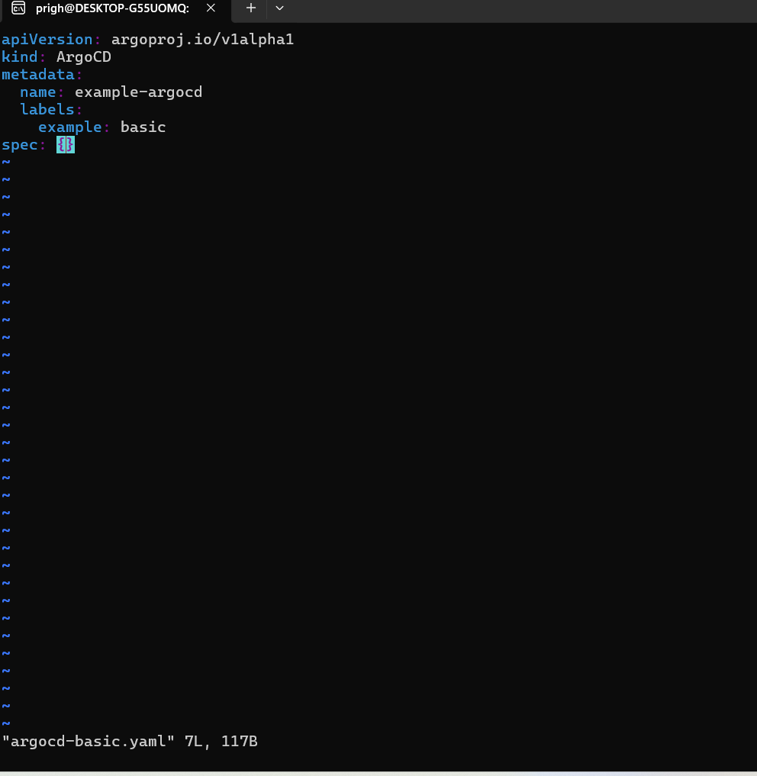

* Apply argocd-basic

*kubectl apply -f argocd-basic.yaml*

* Check the pods

*kubectl get pods*

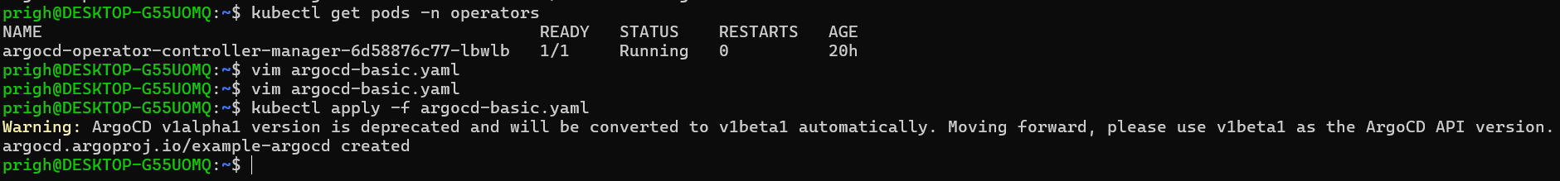

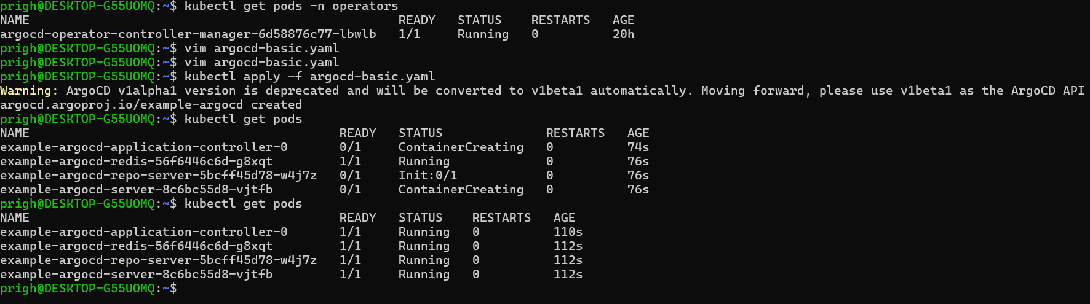

* In svc, type is clusterip change it to nodeport because we want to run on browser.

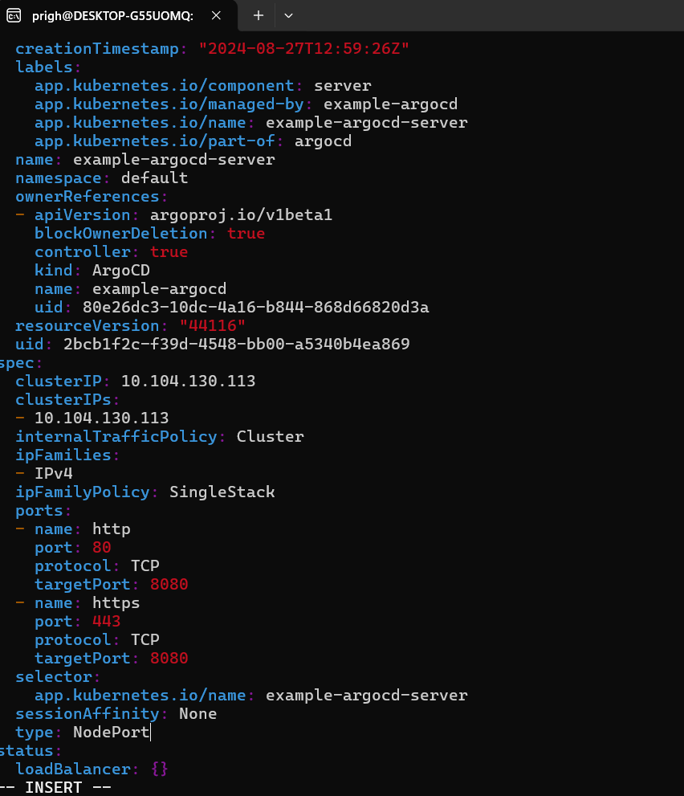

* Get the list of svc and the minikube service list.

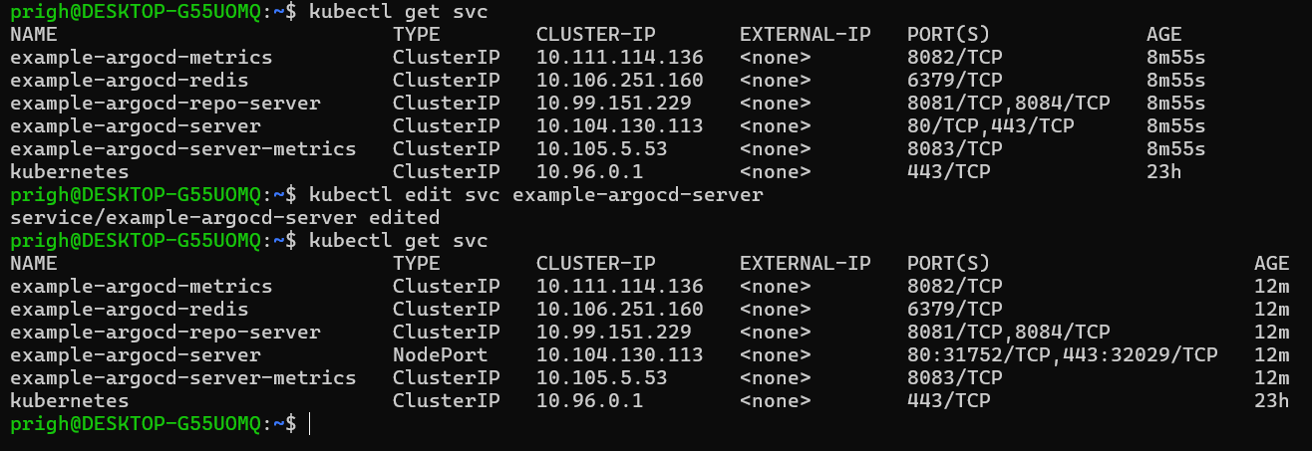

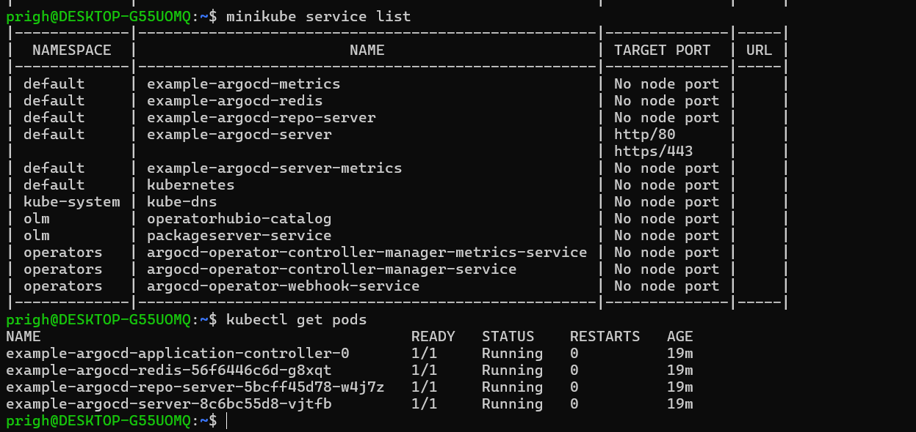

Minikube service example-argocd-server

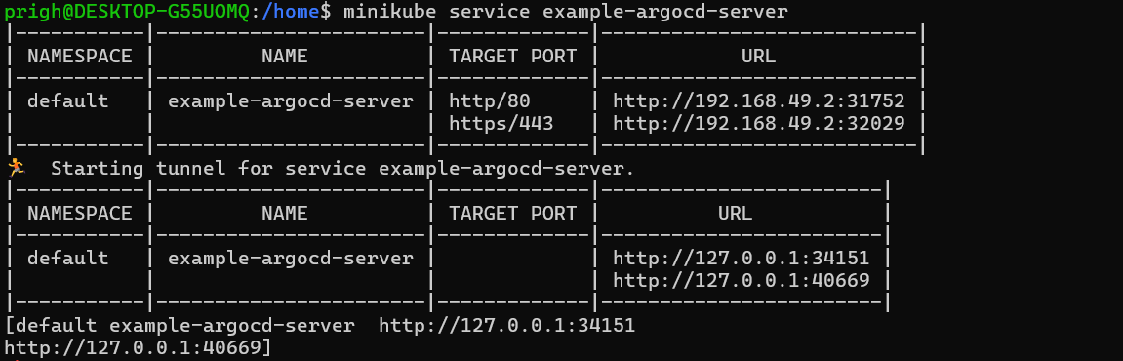

1. Copy the URL example-argocd-server and run on browser. You will get argocd started window.

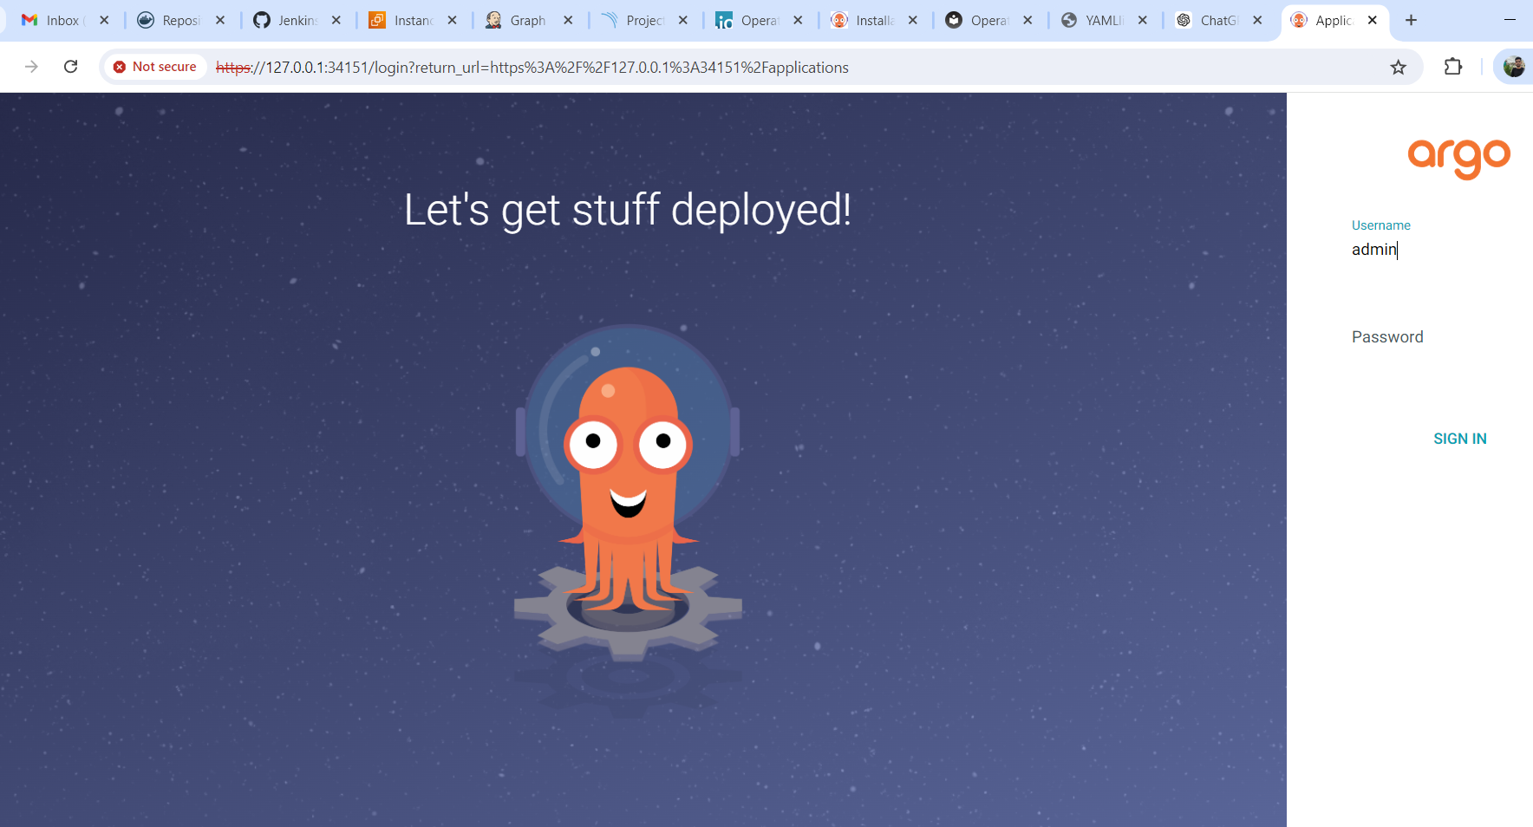

* check the secret on minikube and sign in argocd.

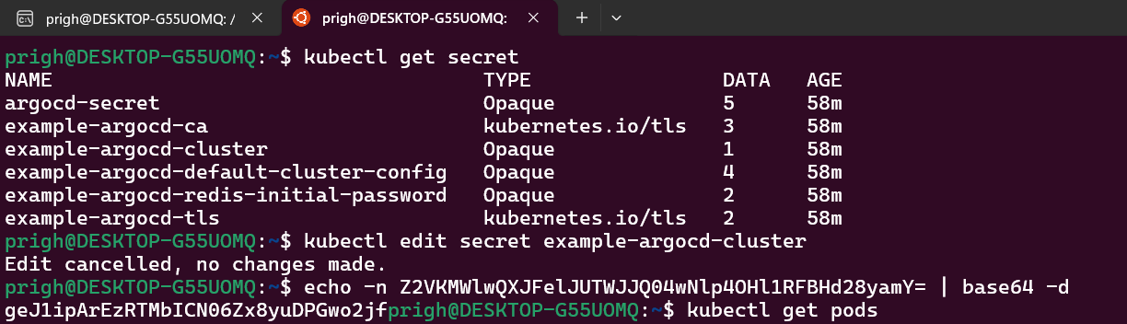

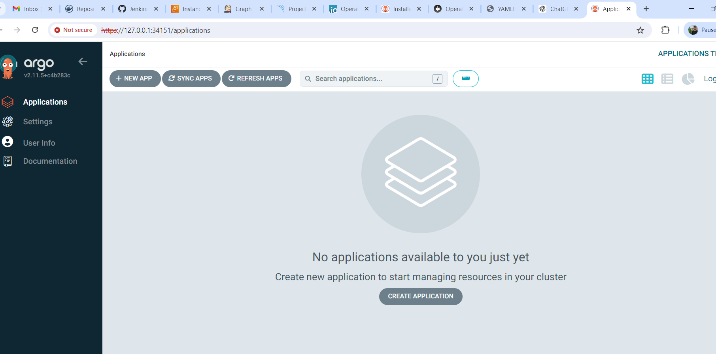

* Create the application and add the summary + create.

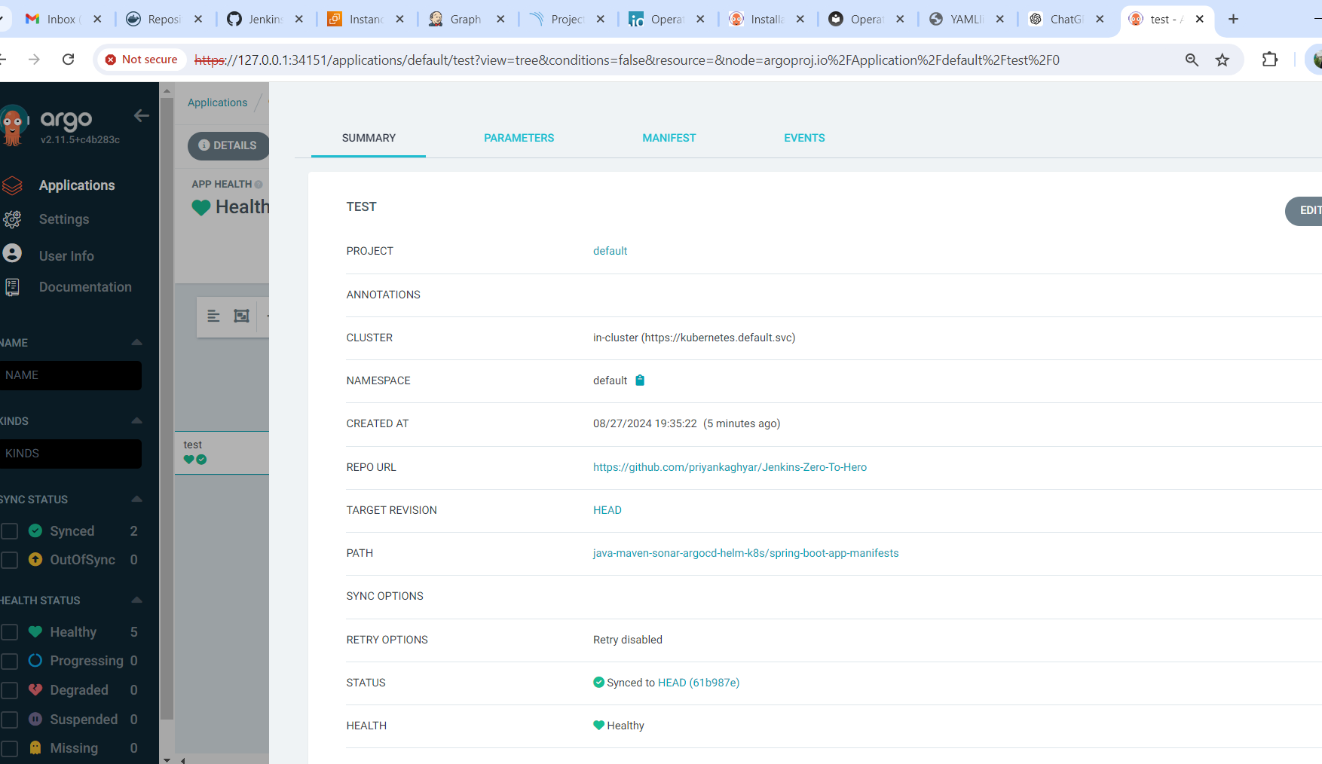

* Application is successfully deployed on argocd. App status is healthy and sync is ok.

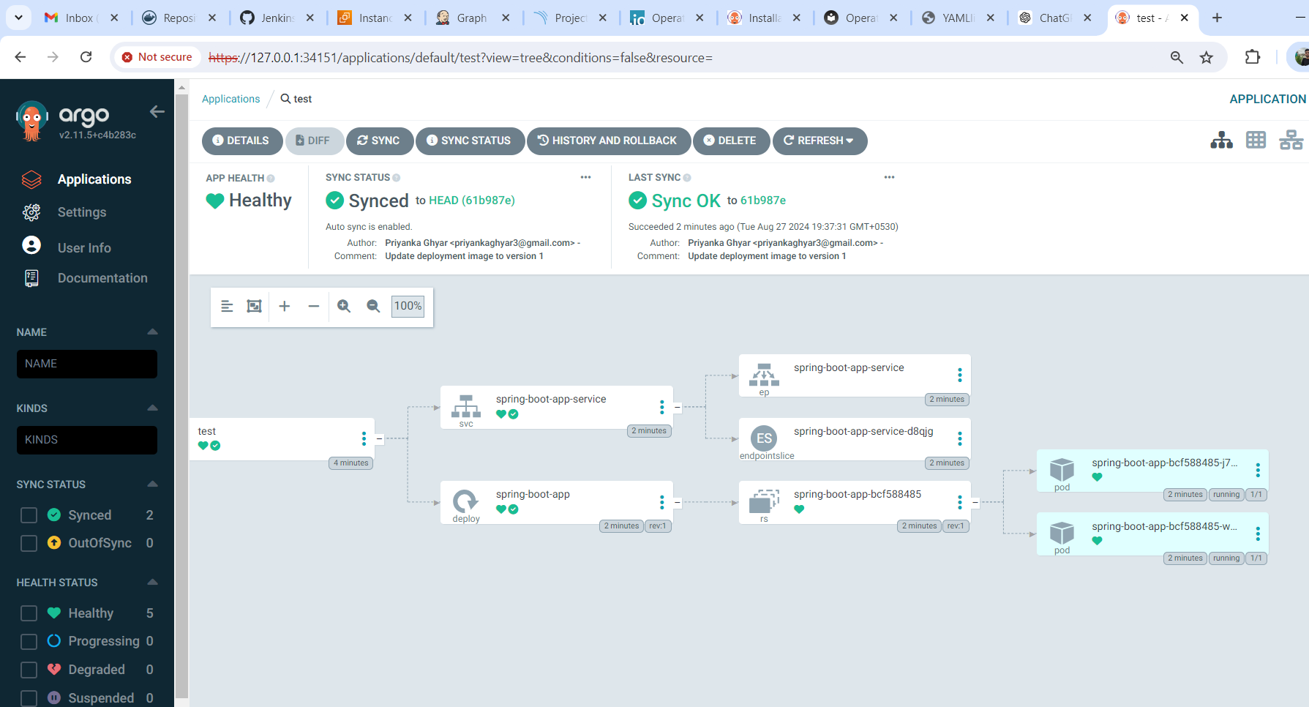

* New 2 pods also running 😊.

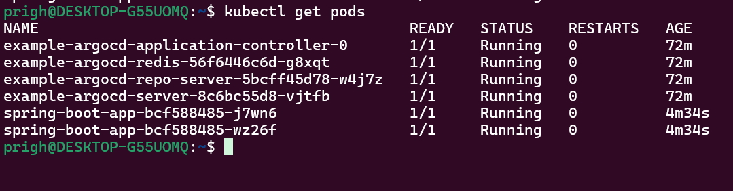



**Ultimate CICD Jenkins Pipeline is successfully Done.!!**